**Formative Assignment __**

|  |  |
| --- | --- |
| Module Name | Application Integration |
| Course Name | Bachelor’s Degree in Software Engineering |
| Assignment Title | Implement O Auth Integration for SignUp |

|  |  |
| --- | --- |
| Learner Name | Francis Roel L. Abarca |

|  |
| --- |
| Learner declaration |
| I certify that the work submitted for this assignment is my own and research sources are fully acknowledged.  Student signature: Date: 5/25/23 |

**Trainer--- University training, SSG training,**

**Content development**

**Scope of this Assignment**

The scope of this assignment is to implement O Auth Integration for SignUp

using Facebook for ‘XYZ Cars Pte Ltd’.

These are the steps provided to build an API.

1. Create developers Account on Facebook

2. Create New Application for using social integration.

3. Implement Social login using Facebook in XYZ cars Portal.

4. Use created App Id and App Secret in Application.

5. Login using Facebook.

**Task Wise Solutions**

1. Create developers account on Facebook
   1. Create your Meta Developer account then once you have created it, go to the App section.  
      A screenshot of a computer

      Description automatically generated with medium confidence
2. Create New Application for using social integration.
   1. Inside the app section, Create an App then select “Set up Facebook Login” then click Next.A screenshot of a computer screen

      Description automatically generated with low confidence
   2. Inside Facebook Login, under “Which platform will you use for your app?” select Windows App and under “Are you building a game?”, select “No, I’m not building a game” then click next.A screenshot of a computer

      Description automatically generated with medium confidence
   3. Name your app then select the appropriate App contact email and Business account you want for your app then click Create app.A screenshot of a computer

      Description automatically generated with medium confidence
   4. You will be prompted to enter your password after creation. A screenshot of a computer screen

      Description automatically generated with medium confidence
   5. Once you are done, you will be greeted with the Dashboard site for your newly created app. 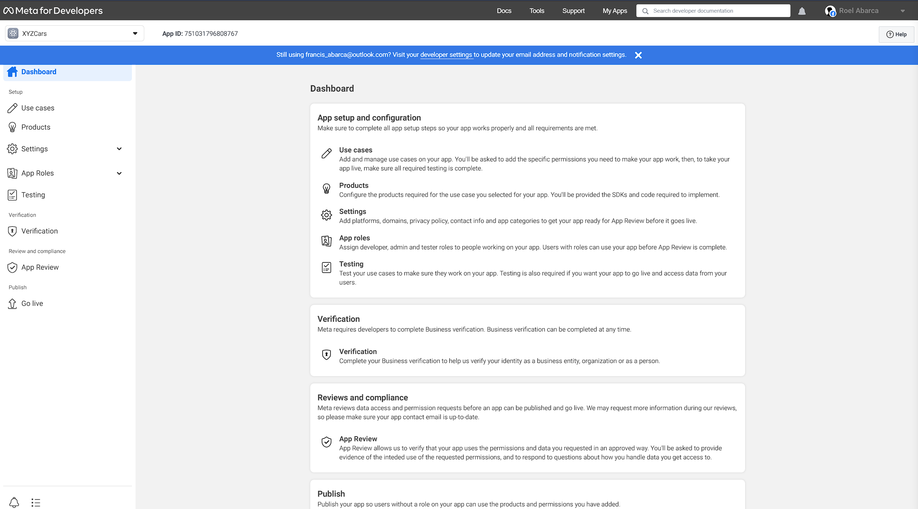
3. Implement Social login using Facebook in XYZ Cars Portal.
   1. AuthController.java  
      A screen shot of a computer program

      Description automatically generated with medium confidence
   2. OAuth2Config.javaA screenshot of a computer program

      Description automatically generated with medium confidence
   3. Index.html  
      A screenshot of a computer program

      Description automatically generated with medium confidence
4. Use created App Id and App Secret in Application.
   1. Application.ymlA screenshot of a computer program

      Description automatically generated with medium confidence
5. Login using Facebook.
   1. Open the address (http://localhost:3000): A screenshot of a computer

      Description automatically generated with medium confidence
   2. Click on the “Login” button. A picture containing text, font, screenshot, logo

      Description automatically generated
   3. Inside Login, click on “Login with Facebook” A screenshot of a computer

      Description automatically generated with medium confidence
   4. You will be prompted to enter you Facebook credentials. A screenshot of a login page

      Description automatically generated with medium confidence
   5. Enter them promptly then click on Log-in.A screenshot of a login page

      Description automatically generated with medium confidence
   6. If you have 2 factor authentication enabled for Facebook, comply with the requirements. A screenshot of a computer

      Description automatically generated with medium confidence
   7. Once done, you will be greeted with a “Logged in as” message with your name on it and prompting you to click on the Home link to go back to the front-end. A picture containing text, screenshot, font

      Description automatically generated